SIMATS ENGINEERING
ASSESSMENT TOOL 3
COURSE NAME: Computer Vision with OpenCV COURSE CODE: DSA0202
COURSE OUTCOME COVERED
CO2: Apply image processing and feature extraction techniques, including edge detection, motion estimation, and optical flow, for analyzing images.. (BL3)
Assessment Tool Weightage: 20%
QUESTIONS: 2 Total Marks:20 Annexure A
Class Test
Code of Conduct:
I N.JOE JERISH(192524374) certify that this submission is my original work and that I have adhered to the guidelines specified for this assessment.
I understand that any violation of academic integrity rules will result in disciplinary action. Signature of the student:
RUBRICS FOR CALCULATION
Criteria | Weighta  ge | Level 4 – Exemplary | Level 3 –  Proficient | Level 2 –  Developing | Level 1 –  Beginning | Marks
Understand ing of  Concepts | 25% | Demonstrates thorough, accurate understanding of concepts | Good  understanding  with minor gaps | Basic  understanding  with some  misconceptions | Poor  understanding; major  misconceptions
Explanatio n | 25% | Detailed, well  explained answers with relevant examples | Clear explanation with adequate  details | Limited  explanation;  lacks depth | Poor or unclear explanation
Applicatio  n | 20% | Effectively applies  concepts with strong analytical ability | Applies concepts with minor errors | Limited  application with weak analysis | No application or incorrect  analysis
Organizati  on | 15% | Well-structured  answers with logical flow and coherence | Organized with minor issues in flow | Basic structure, lacks clarity | Poor  organization,  incoherent  answers
Accuracy | 10% | Completely accurate and covers all required points | Mostly accurate with minor  omissions | Partially correct with missing  points | Incorrect  answers with  major gaps
Clarity | 5% | Clear, neat,  professional  presentation | Understandable with minor issues | Limited clarity, readability issues | Poorly written, difficult to  understand

Annexure A
Class Test
Question 1: Image Preprocessing and Feature Extraction
Scenario: A drone is used to capture aerial images of a farmland to identify pest affected crop regions. Due to sensor limitations, wind movement, and changing sunlight, the captured images contain noise, shadows, and uneven illumination. Pest affected areas usually show visible texture and color variations compared to healthy crop regions.
Answer the following questions:
a) Preprocessing Pipeline — 4 Marks
Propose a suitable preprocessing pipeline to improve the quality of the farmland images before analysis. Your answer should include methods for noise reduction, illumination correction, contrast enhancement, and normalization. Justify the purpose of each step.
b)Feature Extraction — 3 Marks
Choose an appropriate feature extraction method to identify texture changes caused by pest damage. Explain why the selected method is suitable for detecting affected crop regions.
c)Rotation and Scale Variations — 3 Marks
Drone images may be captured from different heights and angles. Discuss how rotation and scale variations can affect feature detection. Suggest suitable methods to make the feature extraction process more robust.
Question 2: Stereo Vision and Motion Estimation
Scenario: A self-driving car is equipped with stereo cameras to navigate through a busy street. The system must estimate the distance of nearby vehicles and pedestrians in real time. It should also track moving objects accurately to avoid collisions, especially when pedestrians or vehicles change speed suddenly.
Answer the following questions:
a) Stereo Disparity and Depth Estimation — 4 Marks
Explain how stereo cameras use the difference between left and right image views to estimate the depth of objects. Discuss how disparity changes for nearby and distant objects.
b) Optical Flow for Motion Tracking — 3 Marks
If a pedestrian suddenly changes speed or direction, explain how optical flow helps in tracking the pedestrian’s motion between consecutive video frames. c) Errors and Mitigation Techniques — 3 Marks
Identify possible sources of error in depth estimation and motion tracking, such as camera misalignment, poor lighting, occlusion, fast motion, or textureless regions. Suggest suitable techniques to reduce these errors.

Question 1 — Image Preprocessing and Feature Extraction
Scenario: A drone captures aerial farmland images to identify pest-affected crop regions. The images contain noise, shadows, and uneven illumination caused by sensor limitations, wind movement, and changing sunlight. Pest-affected areas show visible texture and color variation compared to healthy crop regions.
a) Preprocessing Pipeline
A four-stage pipeline addresses the noise, shadow, and illumination problems in sequence, since each stage assumes a relatively clean input from the one before it:
- 1. Noise Reduction — A bilateral filter (or median filter for salt-and-pepper sensor noise) is applied first. Unlike a simple Gaussian blur, the bilateral filter smooths flat regions while preserving crop-edge boundaries, which is essential because edge and texture information is exactly what later pest-detection steps depend on.
- 2. Illumination Correction — Shadows and uneven sunlight are corrected using CLAHE (Contrast Limited Adaptive Histogram Equalization) applied on the luminance (L) channel of the image in LAB color space, or by homomorphic filtering. This equalizes brightness across the field so that a healthy leaf in shadow is not misclassified as diseased simply because it appears dark.
- 3. Contrast Enhancement — Global or adaptive histogram equalization boosts the contrast between healthy green tissue and pest-affected patches (which are typically yellow/brown or textured differently), making subtle color and texture differences easier for the next stage to detect.
- 4. Normalization — Pixel intensities are rescaled to a common range (e.g., 0–1) and color values are normalized (e.g., white-balance / z-score normalization per channel). This ensures that images captured at different times of day or under different lighting conditions are numerically comparable, which is important since the same pest region should produce similar feature values regardless of when it was photographed.
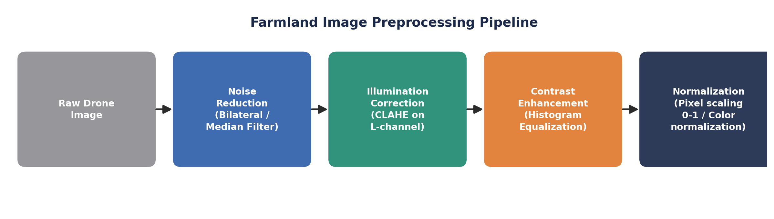
Figure 1: Proposed preprocessing pipeline for the farmland images.
b) Feature Extraction

Texture-based feature extraction is best suited here because pest damage manifests as a change in surface texture (spots, lesions, rough patches) rather than just a simple color shift.
- Recommended method: Gray-Level Co-occurrence Matrix (GLCM). GLCM computes second-order statistics — contrast, homogeneity, energy, and correlation — from the spatial relationship between neighboring pixel intensities.
- Why it suits this scenario: Healthy crop regions have a fairly uniform, repetitive texture, while pest-affected regions show irregular intensity variation. GLCM contrast and homogeneity values change measurably between these two cases, making it possible to numerically separate affected from healthy regions.
- Alternative: Local Binary Patterns (LBP) can also be used — it is computationally lighter and is robust to the illumination changes typical of outdoor drone imagery, making it a practical complement to GLCM.

c) Rotation and Scale Variations
Because the drone captures images from different heights and angles, the same crop region can appear at different sizes (scale) and orientations (rotation) across images.
- Effect on detection: Basic corner detectors (e.g., Harris corner detector) and raw texture descriptors are not scale- or rotation-invariant. A pest patch that is correctly detected at one altitude/angle may go undetected at another because its apparent size or orientation has changed, reducing detection consistency across the dataset.
- Recommended fix: Use scale- and rotation-invariant feature detectors/descriptors such as SIFT (Scale-Invariant Feature Transform) or ORB (Oriented FAST and Rotated BRIEF). These build descriptors that are normalized for local scale and orientation, so the same crop feature is matched reliably regardless of drone height or heading.
- Additional measure: Constructing an image pyramid (multi-scale representation) before feature extraction, combined with geo-referencing/altitude metadata from the drone, further improves robustness by allowing features to be compared at a consistent effective ground scale.

Question 2 — Stereo Vision and Motion Estimation
Scenario: A self-driving car with stereo cameras must estimate the distance to nearby vehicles and pedestrians in real time, and must track moving objects accurately, especially when they change speed suddenly.
a) Stereo Disparity and Depth Estimation
Stereo cameras are mounted a fixed distance apart (the baseline, b). Because of this offset, the same real-world point projects to slightly different horizontal pixel positions in the left and right images — this horizontal pixel-position difference is called disparity (d).
- Depth is recovered using the relation Z = (f × b) / d, where f is the focal length of the camera, b is the baseline distance between the two cameras, and d is the disparity (in pixels) for that point.
- Nearby objects produce a large disparity — their projected position shifts significantly between the left and right images — while distant objects produce a small disparity, since parallax decreases with distance.
- Because disparity is inversely proportional to depth, small errors in disparity matter far more for distant objects than for nearby ones, which is why accurate calibration and precise pixel-level correspondence matching (stereo matching) are critical for reliable depth estimation at range.
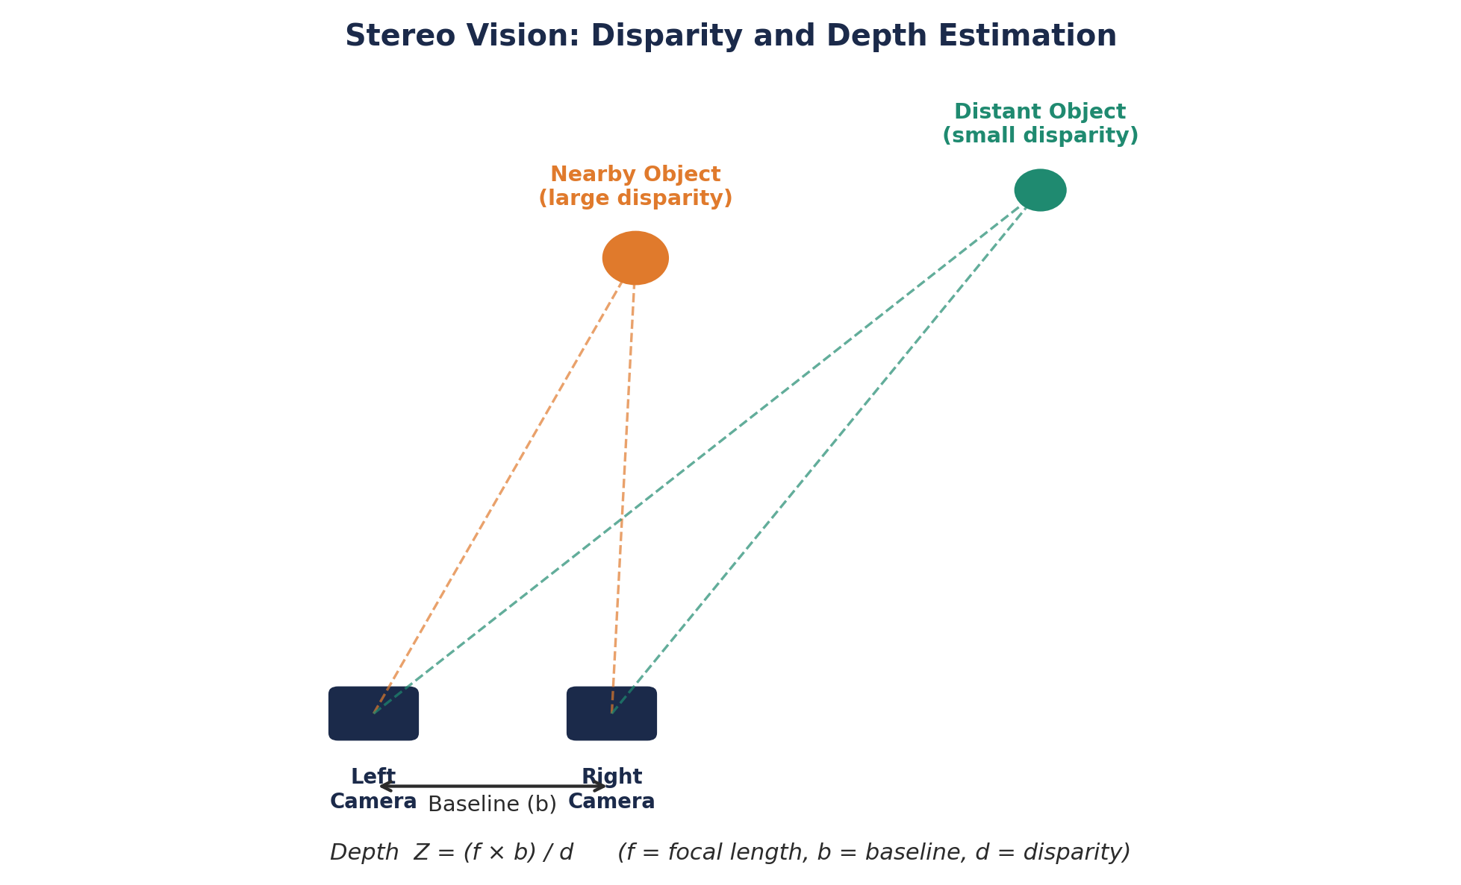
Figure 2: Disparity decreases as object distance from the stereo camera pair increases.
b) Optical Flow for Motion Tracking
Optical flow estimates the apparent motion of pixel intensities between two consecutive video frames, based on the brightness-constancy assumption (a pixel's intensity stays the same as it moves, only its position changes).
- When a pedestrian suddenly changes speed or direction, the optical flow vectors (u, v) computed at the pedestrian's location change in magnitude and direction accordingly, allowing the system to detect the change in motion almost immediately, frame to frame.
- Sparse methods such as Lucas–Kanade optical flow track a set of distinctive keypoints (e.g., corners on the pedestrian's silhouette) efficiently in real time, while dense methods such as Farneback optical flow compute a flow vector for every pixel, giving a fuller picture of the motion field at higher computational cost.
- This continuous vector field lets the self-driving car predict the pedestrian's next position and react (brake/steer) before a collision risk becomes critical.
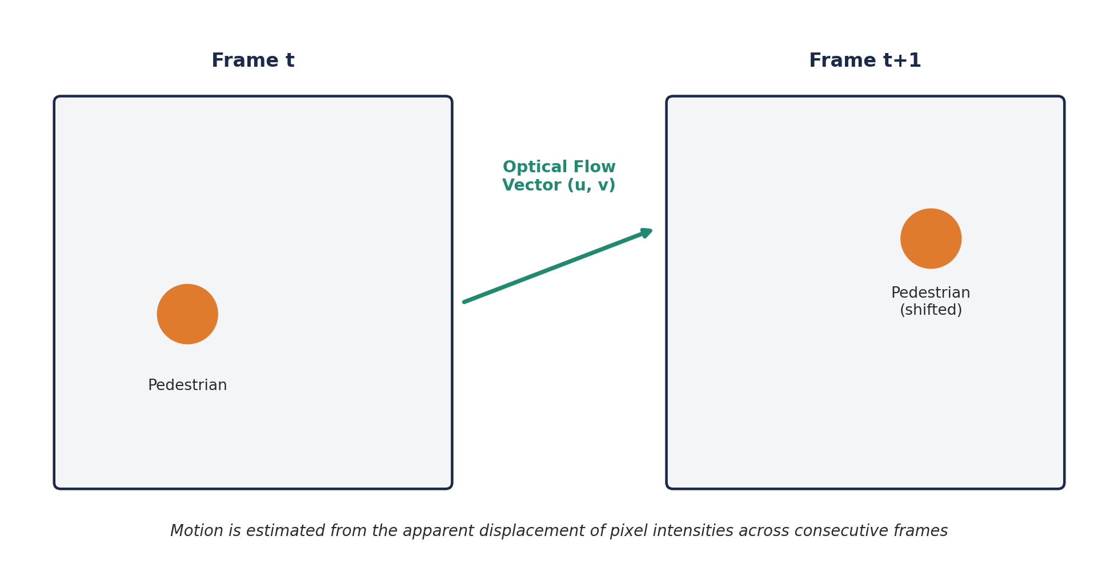
Figure 3: Optical flow vector describing pixel displacement between consecutive frames.

c) Errors and Mitigation Techniques
Several practical factors can degrade depth estimation and motion tracking accuracy:
- Camera misalignment: Even slight physical misalignment of the stereo pair introduces incorrect disparity values. Mitigation: regular stereo calibration and image rectification so that corresponding points lie on the same horizontal scanline.
- Poor lighting: Low light or glare reduces image contrast, making correspondence matching and flow estimation unreliable. Mitigation: illumination normalization/preprocessing, and sensor fusion with LiDAR or radar, which are lighting-independent.
- Occlusion: When one object blocks another, correspondence or tracking is temporarily lost. Mitigation: multi-frame tracking with prediction (e.g., Kalman filter) to estimate position through brief occlusions.
- Fast motion: Large inter-frame displacement can violate the small-motion assumption behind optical flow and cause motion blur. Mitigation: pyramidal (coarse-to-fine) Lucas–Kanade optical flow and higher frame-rate capture.
- Textureless regions: Flat, uniform surfaces (e.g., a plain wall or road) provide few distinctive features for matching, causing ambiguous correspondences. Mitigation: semi-global matching (SGM) for stereo, and fusing camera data with other sensors that do not rely on texture, such as LiDAR.

